Tab 1



Project Name : Task Management Project (CompantBuddy)

Table of contents

Chapter 1 - intro of project , hardware software requirements

Chapter 2 technology used, frontend tech, backend tech frontend and backend tool

Chapter 3 system analysis and systems study

3.1 project analysis

3.2 feasibility study

3.3 Cost benefit analysis

Chapter 4. Project design

4.1 data dictionary

4.2 dfd(data flow diagram)

4.2.1 Er diagram

4.2.2 System flow chart

4.2.3 Snapshot

Chapter 5 mechanism used

5.1 Testing mechanism

5.2 Incrementation mechanism

Chapter 6 future scope

Chapter 7 reference and bibliography

Chapter 1: Introduction to the Project

1.1 Overview of the Project

The development of this professional Task Management Website addresses the critical need for a centralized and efficient system to manage work within organizations. This robust platform empowers companies and their employees with a comprehensive suite of features designed to streamline task organization, enhance productivity, and improve project outcomes. Employees can easily create, update, and track their individual and team tasks, ensuring clarity and accountability. The system allows for the assignment of priorities and the setting of crucial deadlines, enabling teams to focus on critical activities and meet project milestones effectively. Furthermore, the ability to categorize tasks into distinct projects provides a clear overview of progress and facilitates better resource allocation. The integrated collaboration features enable seamless communication and information sharing among team members, fostering a more cohesive and productive work environment. ¹ Ultimately, this Task Management Website serves as a vital tool for companies seeking to optimize their operational efficiency, improve project management, and empower their workforce with a clear and organized approach to their responsibilities.

1.2 Objectives of the Project

This project is driven by several key objectives, each contributing to the creation of a powerful and effective Task Management Website for companies and their employees.
1. Provide an Intuitive Interface for Task Management: A primary objective is to develop a user-friendly and intuitive interface that simplifies the complexities of task management. The platform will be designed with a clear and logical layout, ensuring that employees can easily navigate and interact with all features without requiring extensive training. This involves creating a seamless experience for creating new tasks with minimal effort, updating task details efficiently, and readily accessing relevant information. The interface will prioritize ease of use, employing clear visual cues, logical workflows, and responsive design principles to ensure accessibility across various devices. By focusing on user experience, we aim to encourage consistent adoption and maximize the platform's effectiveness in daily task management.
2. Improve Productivity by Organizing Tasks Effectively: A core objective of this project is to significantly enhance individual and team productivity through effective task organization. The website will empower users to structure their workload logically by categorizing tasks into projects, assigning priorities to focus on critical activities, and setting clear deadlines to maintain momentum. Features such as sub-tasks will allow for the breakdown of larger assignments into manageable steps, promoting a sense of progress and reducing overwhelm. By providing tools for clear task definition, prioritization, and structured organization, this platform aims to minimize wasted effort, improve time management, and ultimately boost overall productivity across the organization.
3. Enable Collaboration in Team-Based Environments: Recognizing the importance of teamwork in a professional setting, a crucial objective is to facilitate seamless collaboration within team-based environments. The Task Management Website will incorporate features that allow for easy task assignment to multiple team members, shared visibility of task progress, and integrated communication tools. This may include commenting features within tasks, shared file attachments, and potentially direct messaging capabilities to streamline discussions and reduce reliance on external communication channels. By fostering transparency and providing tools for effective teamwork, this platform aims to improve communication, enhance accountability, and ensure that teams can work together efficiently towards common goals.
4. Ensure Data Security and User Authentication: A paramount objective of this project is to guarantee the security and integrity of all user data and to implement robust user authentication mechanisms. The platform will be developed with industry best practices for data encryption, storage, and transmission to protect sensitive company information. Secure user authentication protocols, including strong password requirements and potentially multi-factor authentication, will be implemented to prevent unauthorized access. Regular security audits and updates will be conducted to maintain a high level of data protection and ensure the confidentiality and integrity of all information stored within the Task Management Website. Building user trust through a secure and reliable platform is a fundamental goal of this project.

1.3 Hardware Requirements (Client-Side)
These are the recommended minimum hardware specifications for a user's computer to effectively access and interact with the Task Management Website:
- Processor: Intel Pentium 4 or equivalent processor. While the website is designed to be lightweight, a processor of this caliber or higher will ensure smooth rendering and responsiveness, especially with dynamic content and interactive elements. For a noticeably better experience, an Intel Core i3 or equivalent is recommended.
- RAM: 1GB of RAM. This is the absolute minimum to run a modern web browser adequately. However, for a smoother experience, especially if the user has multiple browser tabs open or is running other applications simultaneously, 4GB of RAM is highly recommended. Insufficient RAM can lead to slower loading times and potential browser instability.
- Storage: Minimal impact on local storage. The website itself does not require significant local storage on the user's machine beyond the browser's cache and temporary files (typically less than 500MB). The core application and data reside on the server.
- Display: A monitor with a resolution of at least 1024x768 pixels is recommended for proper rendering of the website layout and all its elements. Higher resolutions will provide a more spacious and detailed view.
- Internet Connection: A stable internet connection is essential to access the Task Management Website. The bandwidth requirement will depend on the frequency of data updates and the size of any attached files. A broadband connection (e.g., DSL, cable, fiber) is recommended for a seamless experience.

1.4 Software Requirements
This section outlines the software requirements for both accessing the Task Management Website as a user and the software utilized in its development and deployment (given it was built using the MERN stack).
For Users Accessing the Website:
- Operating System: Users can access the Task Management Website using any modern operating system that supports contemporary web browsers, including but not limited to:
  - Windows 10
  - Windows 11
  - macOS (various versions)
  - Linux (various distributions)
  - ChromeOS
- Web Browser: A modern and up-to-date web browser is required to interact with the Task Management Website. Optimal performance and compatibility are expected with the latest stable versions of:
  - Google Chrome
  - Mozilla Firefox
  - Microsoft Edge
  - Safari (on macOS) JavaScript must be enabled in the browser settings for the website's interactive features to function correctly.
For Development and Deployment (MERN Stack):
The following software and technologies were utilized in the development and deployment of this Task Management Website:
- Development Tools:
  - Code Editor: Visual Studio Code (VS Code) was the primary Integrated Development Environment (IDE) used for writing and managing the codebase. Git integration within VS Code was also utilized for version control.
  - Version Control System: Git was used for tracking changes to the codebase and collaborating with team members. A Git repository (e.g., on GitHub, GitLab, Bitbucket) was utilized for this purpose.
- Backend Server:
  - Node.js: The JavaScript runtime environment that powers the backend of the application. A stable Long-Term Support (LTS) version of Node.js is required on the server.
  - npm (Node Package Manager) or yarn: Package managers used to install and manage backend dependencies, including the Express.js framework and MongoDB drivers.
  - Express.js: A lightweight and flexible Node.js web application framework used to build the RESTful API endpoints for the Task Management Website.
- Frontend Library/Framework:
  - React.js: A JavaScript library used for building the dynamic and interactive user interface of the website.
- Database:
  - MongoDB: A NoSQL, document-oriented database used to store the application's data, such as user information, tasks, and project details. A MongoDB server instance is required for the backend to connect to.

1.4 Usage Guide for CompanyBuddy - Task Management System
This guide provides a step-by-step overview of how to use the core features of CompanyBuddy to effectively manage tasks and collaborate with your team, starting from accessing the platform.
Getting Started:
- Access CompanyBuddy: Open your preferred web browser and navigate to the CompanyBuddy website : https://college-task-frontend.vercel.app/
- Login (For Existing Users):
  - On the homepage, locate the "Login" button and click on it.
  - You will be redirected to the login page.
  - Enter your registered Email Address or Username in the designated field.
  - Enter your Password in the corresponding field.
  - Click the "Login" button to access your CompanyBuddy account.
  - If you have forgotten your password, look for a "Forgot Password" link and follow the instructions to reset it.
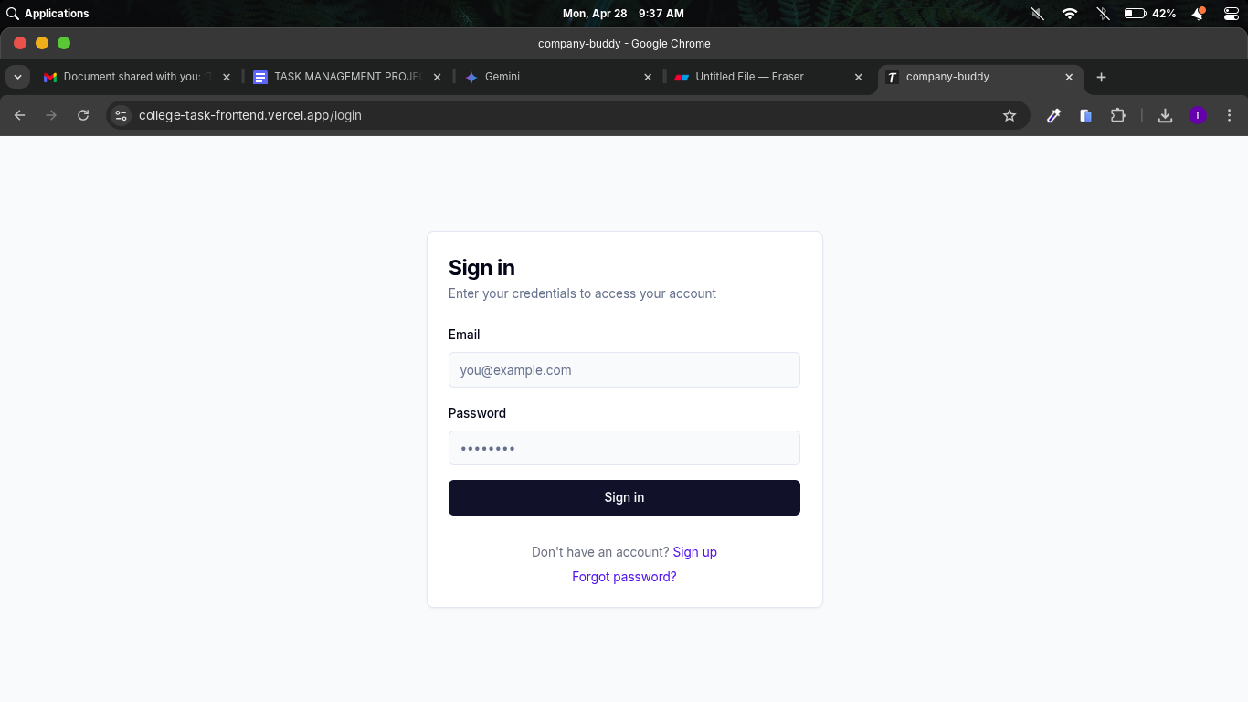
- Signup (For New Users):
  - On the homepage, locate the "Signup" or "Register" button and click on it.
  - You will be redirected to the registration page.
  - Fill out the required information, which typically includes:
    - Username: Choose a unique username for your account.
    - Email Address: Enter a valid email address. This will be used for communication and account recovery.
    - Password: Create a strong and secure password. Follow any password requirements specified on the page.
    - Confirm Password: Re-enter your password to ensure it matches.
  - You may be asked to agree to the platform's terms of service and privacy policy.
  - Click the "Signup" or "Register" button to create your account.
  - You may receive a confirmation email to verify your email address. Follow the instructions in the email to activate your account.
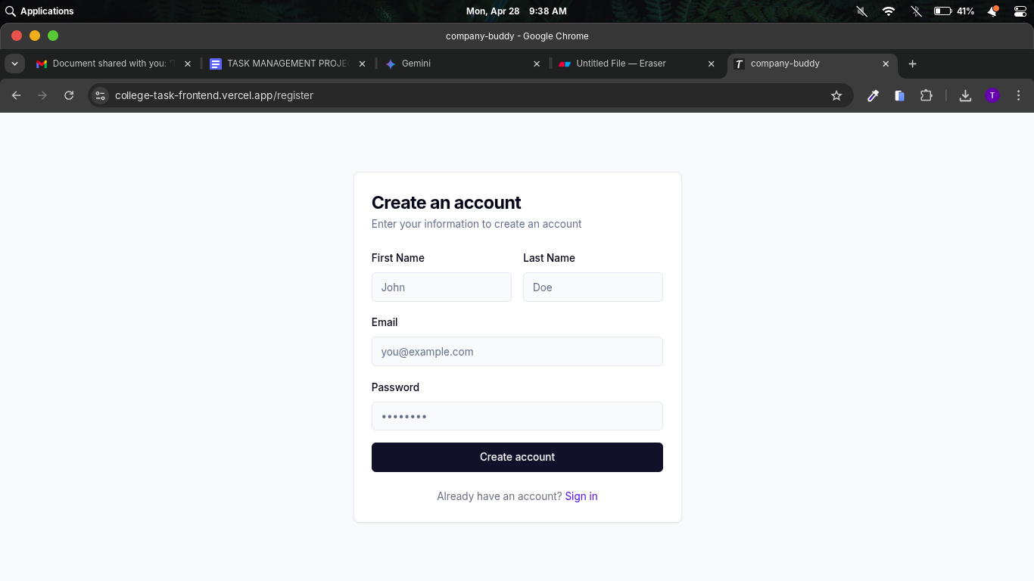
After Logging In:
- Navigate to Dashboard: Once you have successfully logged into CompanyBuddy, you will be directed to your personal dashboard. This is your central hub for accessing different features and managing your work.
Creating a Company:
- Click "Create Company": On the dashboard, locate and click the button labeled "Create Company." This action will initiate the company creation process.
- Enter company details: A form will appear, prompting you to enter essential information about your company. This may include the company name, a brief description, and potentially other relevant details. Fill out all the required fields accurately.
- Invite team members: After successfully creating your company profile, you will be given the option to invite your team members to join. You can typically do this by entering their email addresses. Each invited member will receive an invitation to join CompanyBuddy and your company's workspace.
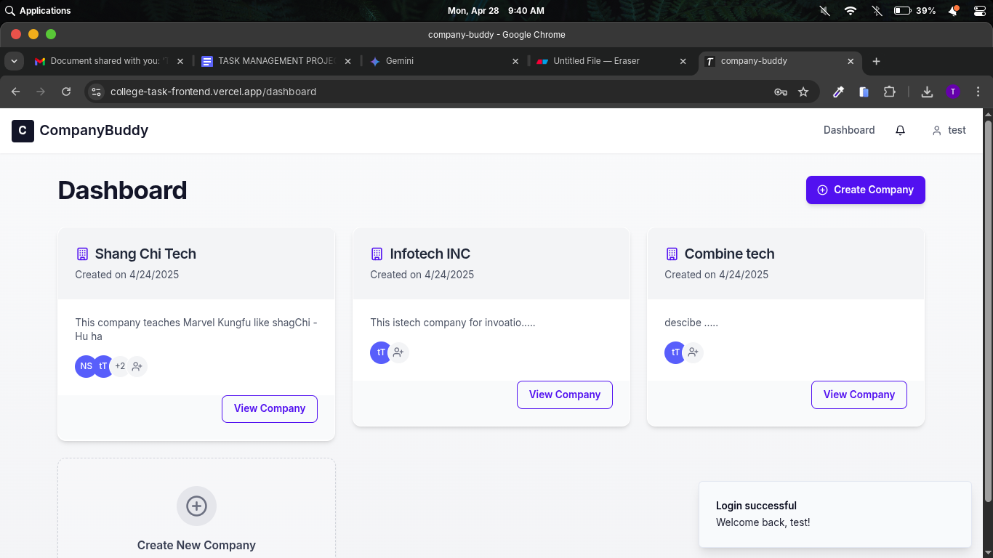
Managing Tasks:
- Open a company: From your dashboard, select the specific company workspace you want to manage tasks within. Clicking on the company name or its associated icon will open the task management interface for that company.
- Click "New Task": Within the company workspace, locate and click the "New Task" button. This will open a form where you can input the details of the task.
- Fill task details: In the "New Task" form, provide comprehensive information about the task. This includes:
  - Task Title: A concise and descriptive name for the task.
  - Description: Detailed instructions, context, and any necessary information related to the task.
  - Due Date: The specific date and time by which the task needs to be completed.
  - Priority: Assign a priority level (e.g., High, Medium, Low) to indicate the urgency of the task.
  - Status: Initially, the status will likely be "Pending" or "To Do."
  - Attachments: You may have the option to upload relevant files or documents to the task.
- Assign to team member: You can assign the task to one or more specific team members who are responsible for its completion. A dropdown menu or a selection list will typically allow you to choose from the invited members of your company.
- Track progress via status updates: As team members work on the task, they can update its status (e.g., "In Progress," "On Hold," "Completed"). These status updates will be visible to all relevant team members, allowing you to track the progress of each task within the company workspace.
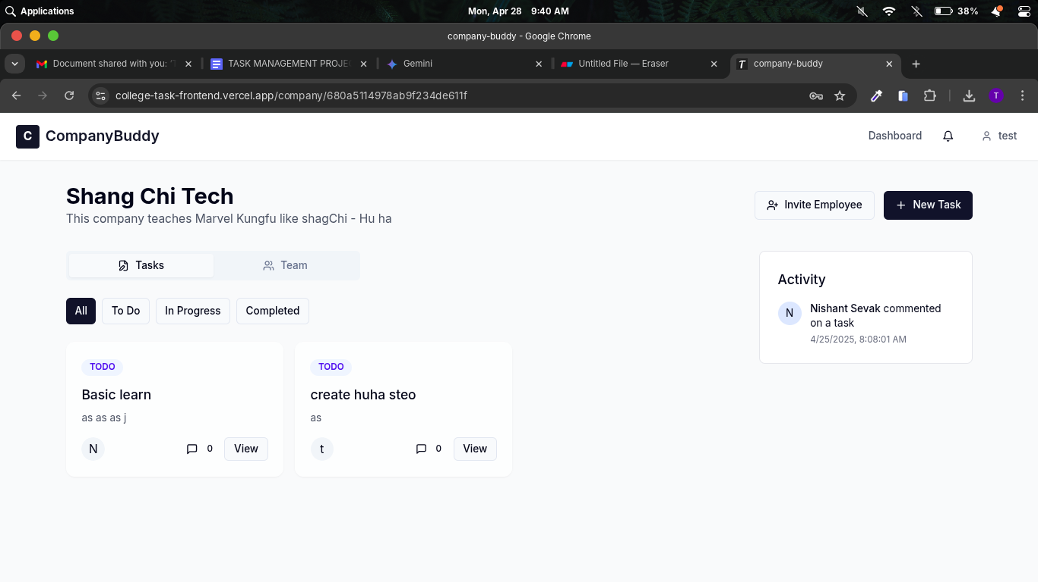
Team Collaboration:
- Comment on tasks: Within each individual task, there will be a section for comments. This feature allows team members to communicate directly about the specific task, ask questions, provide updates, and share relevant information, keeping all task-related discussions centralized.
- View recent activity: The CompanyBuddy platform will likely have an "Activity" feed or a similar section that provides a chronological overview of recent actions within the company workspace. This includes new task creation, status updates, comments, and other relevant activities, keeping everyone informed about the latest developments.
- Manage team members: As an administrator or a designated role within the company workspace, you will have the ability to manage the team members associated with the company. This may include inviting new members, removing members, and potentially assigning different roles or permissions within the platform.

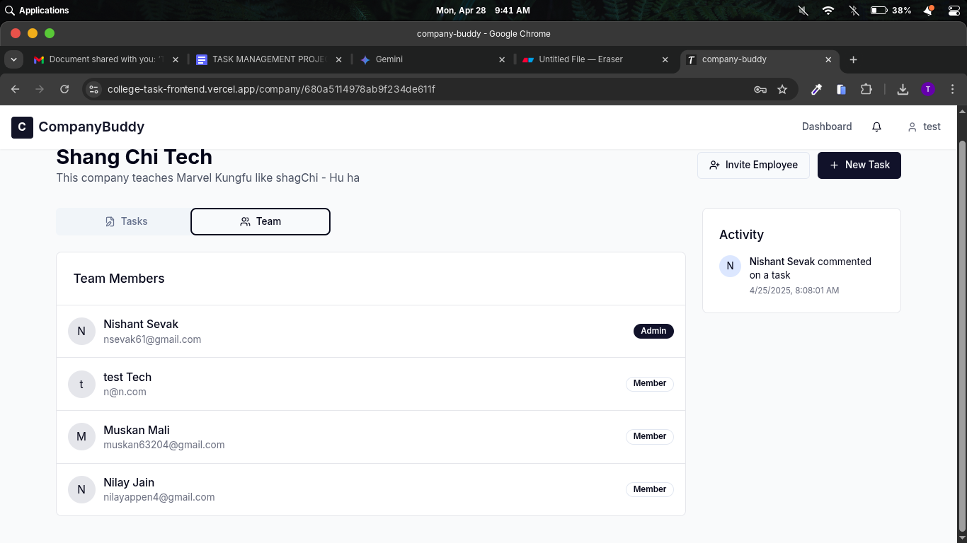

1.5 Project Structure
The CompanyBuddy - Task Management System codebase is organized into a logical directory structure within the src/ directory to promote maintainability, scalability, and separation of concerns. Below is a breakdown of the main directories and their contents:
src/
├── components/ # Reusable UI components used throughout the application.
│ ├── CommentSection.tsx # Component for displaying and managing comments on tasks.
│ ├── Navbar.tsx # The main navigation bar visible across different pages.
│ ├── NewTaskForm.tsx # Form used for creating new tasks with various input fields.
│ ├── TaskCard.tsx # Component for displaying individual task information in a concise format.
│ └── ui/ # A sub-directory containing more generic and reusable UI elements (e.g., buttons, modals, input fields).
├── context/ # Provides a way to share state across the component tree without passing props manually at every level.
│ └── AuthContext.tsx # Context related to user authentication, managing login status and user information.
├── hooks/ # Contains custom React hooks that encapsulate reusable logic and stateful behavior that can be used across different components.
├── pages/ # Contains the main page-level components that represent different views of the application.
│ ├── Company.tsx # The main dashboard or interface for a specific company, displaying tasks, members, and activities related to that company.
│ ├── Dashboard.tsx # The user's personal dashboard, providing an overview of their companies, assigned tasks, and potentially other personalized information.
│ └── ... # Other page components such as Login, Signup, Profile settings, etc.
├── services/ # Contains modules responsible for handling API interactions and data fetching from the backend.
│ └── api.ts # An API client module that likely contains functions for making HTTP requests to the backend API endpoints (defined in the API Reference).
└── types/ # Contains TypeScript type definitions and interfaces used to ensure type safety and improve code maintainability throughout the application.

Explanation of Key Directories:
- components/: This directory houses the reusable building blocks of the user interface. Components here are designed to be modular and can be used in various parts of the application. The sub-directory ui/ further organizes more generic UI elements.
- context/: React Context API is used here to manage global application state that needs to be accessible by many components. AuthContext.tsx specifically manages the authentication state of the user.
- hooks/: Custom React hooks allow for the extraction of stateful logic, making components cleaner and the logic reusable across different components.
- pages/: These components represent the distinct screens or views of the application that users navigate to (e.g., the main dashboard, company-specific views).
- services/: This directory contains the logic for interacting with the backend API. The api.ts file likely includes functions for making requests to endpoints for authentication, companies, tasks, etc.
- types/: In a TypeScript project, this directory holds the type definitions (.ts or .tsx files) for data structures, API responses, and component props, providing static typing for better code quality and developer experience.

1.6 API Reference for CompanyBuddy - Task Management System
This section provides a brief overview of the available API endpoints for interacting with the CompanyBuddy - Task Management System. Please note that this is a simplified reference and may not include all available parameters, request bodies, or response structures. For detailed API documentation, please refer to the complete API documentation.
Base URL: /api (This is a general example; the actual base URL may vary depending on the deployment environment in Udaipur, Rajasthan.)
Authentication
- POST /auth/login: User login endpoint.
Request Body (JSON):
JSON
{
"email": "user@example.com",
"password": "yourpassword"
}

Response (JSON - on success): Returns an access token and a refresh token.
JSON
{
"accessToken": "eyJhbGciOiJIUzI1NiIsInR5cCI6IkpXVCJ...",
"refreshToken": "eyJhbGciOiJIUzI1NiIsInR5cCI6IkpXVCJ..."
}

- POST /auth/register: User registration endpoint.
Request Body (JSON):
JSON
{
"username": "newuser",
"email": "newuser@example.com",
"password": "newsecurepassword"
}

Response (JSON - on success): Returns user information and authentication tokens.
JSON
{
"user": {
"id": 123,
"username": "newuser",
"email": "newuser@example.com"
},
"accessToken": "eyJhbGciOiJIUzI1NiIsInR5cCI6IkpXVCJ...",
"refreshToken": "eyJhbGciOiJIUzI1NiIsInR5cCI6IkpXVCJ..."
}

- POST /auth/refresh: Refresh token endpoint. Used to obtain a new access token using a valid refresh token.
Request Body (JSON):
JSON
{
"refreshToken": "eyJhbGciOiJIUzI1NiIsInR5cCI6IkpXVCJ..."
}

Response (JSON - on success): Returns a new access token.
JSON
{
"accessToken": "eyJhbGciOiJIUzI1NiIsInR5cCI6IkpXVCJ..."
}

Companies
- GET /companies: List all companies that the authenticated user is a member of.
  - Authentication: Requires a valid access token in the Authorization header (e.g., Bearer eyJhbGciOiJIUzI1NiIsInR5cCI6IkpXVCJ...).
Response (JSON - on success): Returns an array of company objects.
JSON
[
{
"id": 1,
"name": "Acme Corp",
"description": "Leading innovation...",
"createdAt": "2025-04-28T04:00:00.000Z",
"updatedAt": "2025-04-28T04:00:00.000Z"
},
{
"id": 2,
"name": "Beta Industries",
"description": "Driving progress...",
"createdAt": "2025-04-27T10:30:00.000Z",
"updatedAt": "2025-04-27T10:30:00.000Z"
}
]

- POST /companies: Create a new company.
  - Authentication: Requires a valid access token.
Request Body (JSON):
JSON
{
"name": "New Startup Inc",
"description": "Disrupting the market..."
}

Response (JSON - on success): Returns the newly created company object.
JSON
{
"id": 3,
"name": "New Startup Inc",
"description": "Disrupting the market...",
"createdAt": "2025-04-28T04:30:00.000Z",
"updatedAt": "2025-04-28T04:30:00.000Z"
}

- GET /companies/:id: Get details of a specific company.
  - Authentication: Requires a valid access token.
  - Path Parameter: :id - The unique identifier of the company.
Response (JSON - on success): Returns the company object with its details and associated members.
JSON
{
"id": 1,
"name": "Acme Corp",
"description": "Leading innovation...",
"createdAt": "2025-04-28T04:00:00.000Z",
"updatedAt": "2025-04-28T04:00:00.000Z",
"members": [
{
"id": 456,
"username": "john.doe",
"email": "john.doe@example.com"
},
{
"id": 789,
"username": "jane.smith",
"email": "jane.smith@example.com"
}
]
}

Tasks
- GET /tasks: List all tasks within the authenticated user's current company context (this might require a way to specify the company, e.g., via query parameter or context).
  - Authentication: Requires a valid access token.
  - Optional Query Parameters: status, priority, projectId, assigneeId, etc. for filtering.
Response (JSON - on success): Returns an array of task objects.
JSON
[
{
"id": 101,
"title": "Write report",
"description": "Draft the monthly progress report.",
"dueDate": "2025-05-05",
"status": "In Progress",
"priority": "High",
"assigneeId": 456,
"projectId": 201,
"createdAt": "2025-04-28T04:05:00.000Z",
"updatedAt": "2025-04-28T04:15:00.000Z"
},
// ... more tasks
]

- POST /tasks: Create a new task.
  - Authentication: Requires a valid access token.
Request Body (JSON):
JSON
{
"title": "Implement new feature",
"description": "Develop the user authentication module.",
"dueDate": "2025-05-12",
"priority": "Medium",
"assigneeId": 789,
"projectId": 202
}

Response (JSON - on success): Returns the newly created task object.
JSON
{
"id": 102,
"title": "Implement new feature",
"description": "Develop the user authentication module.",
"dueDate": "2025-05-12",
"priority": "Medium",
"assigneeId": 789,
"projectId": 202,
"status": "Pending",
"createdAt": "2025-04-28T04:35:00.000Z",
"updatedAt": "2025-04-28T04:35:00.000Z"
}

- PUT /tasks/:id: Update an existing task.
  - Authentication: Requires a valid access token.
  - Path Parameter: :id - The unique identifier of the task to update.
Request Body (JSON): Contains the fields to update (e.g., title, description, dueDate, status, priority, assigneeId, projectId).
JSON
{
"status": "Completed",
"dueDate": "2025-05-04"
}

Response (JSON - on success): Returns the updated task object.
JSON
{
"id": 101,
"title": "Write report",
"description": "Draft the monthly progress report.",
"dueDate": "2025-05-04",
"status": "Completed",
"priority": "High",
"assigneeId": 456,
"projectId": 201,
"createdAt": "2025-04-28T04:05:00.000Z",
"updatedAt": "2025-04-28T04:40:00.000Z"
}

- DELETE /tasks/:id: Delete a specific task.
  - Authentication: Requires a valid access token.
  - Path Parameter: :id - The unique identifier of the task to delete.
Response (JSON - on success): Typically returns an empty body with a 204 No Content status code, or a success message.
JSON
{
"message": "Task deleted successfully"
  - }

Chapter 2: Technology Used
2.1 Frontend Technologies
The user interface of the Task Management Website is built using a combination of modern web technologies to ensure a responsive, interactive, and engaging user experience.
- HTML5 & CSS3: Structure and Styling: HTML5 (HyperText Markup Language version 5) provides the semantic structure and organization of the website's content. It defines the different elements on the page, such as headings, paragraphs, forms, and buttons, ensuring a well-organized and accessible layout. CSS3 (Cascading Style Sheets version 3) is responsible for the visual presentation and styling of the website. It controls aspects like colors, fonts, layout, animations, and overall aesthetics, contributing to a polished and user-friendly interface. The combination of HTML5 and CSS3 ensures a clear separation between content and presentation, making the website maintainable and adaptable.
- JavaScript (ES6+): Dynamic Functionality: JavaScript, specifically ECMAScript version 6 and beyond (ES6+), is the programming language that brings interactivity and dynamic behavior to the Task Management Website. It handles user interactions, manipulates the Document Object Model (DOM) to update the interface in real-time without full page reloads, manages data fetching from the backend, and implements various client-side functionalities. ES6+ introduces modern language features that enhance code readability and maintainability, contributing to a more efficient development process and a smoother user experience.
- React.js: Frontend Framework: As the project was developed using the MERN stack, React.js serves as the primary frontend framework. React is a declarative, component-based JavaScript library for building user interfaces. It enables the creation of reusable UI components, making the development process modular ¹ and efficient. React's virtual DOM and efficient rendering mechanisms contribute to a fast and responsive user interface, providing a seamless experience even with complex interactions and data updates. Its strong ecosystem and large community provide access to numerous libraries and tools that enhance the functionality and scalability of the Task Management Website

Okay, let's elaborate on the "Backend Technologies" and "Frontend and Backend Tools" sections, specifically focusing on Node.js and Express.js given the MERN stack context.
2.2 Backend Technologies
The server-side logic and API for the Task Management Website are built using robust and scalable technologies to ensure efficient data management, secure authentication, and seamless communication with the frontend.
- Node.js (Express.js): Server-side Logic: As part of the MERN stack, Node.js serves as the runtime environment for the backend of the application. Node.js is a JavaScript runtime built on Chrome's V8 JavaScript engine, allowing developers to use JavaScript for both frontend and backend development, promoting code sharing and developer efficiency. Express.js is a minimal and flexible Node.js web application framework that provides a powerful set of features for building web applications and APIs. It simplifies routing, middleware integration, request handling, and response generation, forming the foundation for the Task Management Website's server-side logic and API endpoints.
- RESTful API: Communication between Frontend & Backend: The Task Management Website utilizes a RESTful (Representational State Transfer) API for communication between the React.js frontend and the Node.js/Express.js backend. RESTful APIs are designed around resources, which are uniquely identified by URLs. The frontend interacts with these resources using standard HTTP methods (GET, POST, PUT, DELETE) to perform actions such as retrieving task data, creating new tasks, updating existing ones, and deleting tasks. This architectural style promotes statelessness, scalability, and ease of integration, ensuring a clear and efficient data exchange between the client and the server.
- Authentication: JWT: To ensure the security of user data and the integrity of the application, JSON Web Tokens (JWT) are employed for user authentication. When a user successfully logs in, the backend server generates a JWT, which is a compact and self-contained token containing information about the user's identity. This token is then sent to the frontend and typically stored in the browser. For subsequent requests to the backend, the frontend includes the JWT in the HTTP headers. The backend then verifies the token's signature to authenticate the user and authorize access to protected resources. JWTs provide a stateless and scalable authentication mechanism, crucial for modern web applications.

2.3 Frontend and Backend Tools
A set of essential tools was utilized throughout the development process for managing the codebase, dependencies, and ensuring efficient collaboration.
- Version Control: Git & GitHub: Git is a distributed version control system used to track changes in the codebase over time. It allows developers to collaborate effectively, manage different versions of the code, and revert to previous states if necessary. GitHub serves as a web-based platform for hosting Git repositories. It provides features for collaboration, issue tracking, pull requests, and code review, facilitating a streamlined and organized development workflow for the Task Management Website project.
- Package Managers: npm: As the project leverages Node.js and React.js, npm (Node Package Manager) was the primary package manager used. npm is the default package manager for Node.js and the world's largest software registry. It allows developers to easily install, manage, and update the various libraries and dependencies required by both the frontend (React) and the backend (Express.js) of the Task Management Website. While yarn is another popular JavaScript package manager, npm was likely the primary tool within the MERN stack development environment for this project
Database Management:
- MongoDB Compass: Given that the backend of the Task Management Website utilizes MongoDB as its database, MongoDB Compass is the likely graphical user interface (GUI) tool used for database management. MongoDB Compass provides developers and database administrators with an intuitive way to explore, query, and manage MongoDB databases. It allows for easy visualization of the database schema, running CRUD (Create, Read, Update, Delete) operations through a graphical interface, creating and managing indexes, and analyzing query performance. Compass simplifies interaction with the MongoDB database, making development and administration tasks more efficient compared to using the command-line interface alone.
Deployment:
- Render: Render is a cloud platform that simplifies the deployment of web applications and APIs. It provides an easy-to-use environment for deploying backend applications built with Node.js and frameworks like Express.js. Render handles server configuration, provides automatic TLS certificates, and offers features for scaling and continuous deployment. It's a likely platform for hosting the backend of the Task Management Website, making it accessible online.
- Vercel: Vercel is a platform specifically optimized for deploying frontend web applications built with modern frameworks like React.js. It offers seamless integration with Git repositories, providing automatic deployments on code changes. Vercel's global content delivery network (CDN) ensures fast loading times for the frontend assets, delivering a smooth user experience. It is a strong choice for hosting the React.js frontend of the Task Management Website, leveraging its speed and ease of use for frontend deployments.

Chapter 3: System Analysis and System Study
This chapter delves into the analysis of the Task Management Website project, examining the user needs, defining the system's functional and non-functional requirements, assessing its feasibility from various perspectives, and outlining a preliminary cost-benefit analysis.
3.1 Project Analysis
This section outlines the initial understanding of the project's requirements, gathered through preliminary discussions and analysis of the need for an efficient task management solution.
- User Requirements: These represent the high-level needs and expectations of the individuals who will be using the Task Management Website.
  - Task Creation: Users need the ability to easily create new tasks, specifying details such as task title, description, due date, priority level, and assignees (if applicable in a collaborative setting).
  - Task Categorization: Users require a system to organize their tasks into logical categories or projects, allowing for better management and filtering based on different areas of work or personal life.
  - Reminders: The system should provide a mechanism for setting reminders for tasks, ensuring that users are notified of upcoming deadlines to prevent missed commitments.
  - Collaboration: In team-based environments, users need the ability to share tasks, assign responsibilities, track progress collectively, and communicate within the context of specific tasks or projects.
- Functional Requirements: These define the specific actions and features that the Task Management Website must be able to perform.
  - User Registration/Login: The system must allow new users to register securely and existing users to log in with their credentials to access their personalized task management environment. This includes secure password management and potentially options for password recovery.
  - CRUD Operations for Tasks: The core functionality involves the ability to perform Create, Read, Update, and Delete (CRUD) operations on tasks. Users should be able to add new tasks, view task details, modify existing task information, and remove tasks as needed.
  - Task Filtering & Sorting: To efficiently manage a potentially large number of tasks, the system must allow users to filter tasks based on various criteria (e.g., priority, due date, project, status, assignee) and sort them in different orders to focus on specific sets of tasks.
- Non-Functional Requirements: These define the quality attributes of the Task Management Website, specifying how well the system should perform its functions.
  - Performance (Fast Loading): The website must be designed for optimal performance, ensuring that pages load quickly and user interactions are responsive. This includes efficient database queries, optimized frontend code, and potentially the use of caching mechanisms to minimize latency and provide a seamless user experience.
  - Security (Data Encryption): Protecting user data is paramount. The system must implement robust security measures, including encryption of sensitive data both in transit (e.g., using HTTPS) and at rest (in the database), to prevent unauthorized access and maintain data confidentiality and integrity. Secure authentication mechanisms (as mentioned with JWT) are also crucial.
3.2 Feasibility Study
This section assesses the viability of the Task Management Website project from technical, economic, and operational standpoints.
- 3.2.1 Technical Feasibility:
  - ✔️ Uses well-known frameworks and libraries: The project leverages established and widely adopted technologies like React.js, Node.js, Express.js, and MongoDB. This ensures a large pool of developers with relevant skills, extensive documentation, and active community support, reducing development risks and facilitating efficient problem-solving.
  - ✔️ Scalable architecture: The chosen MERN stack allows for the development of a scalable architecture. React's component-based structure and Node.js's non-blocking I/O model are well-suited for handling increasing user loads. MongoDB's horizontal scalability also provides options for managing growing data volumes. This scalability ensures the application can adapt to future growth.
- 3.2.2 Economic Feasibility:
  - ✔️ Open-source technologies reduce costs: The core technologies used in the MERN stack are open-source and free to use, significantly reducing licensing costs associated with proprietary software. This makes the initial investment and ongoing operational expenses more manageable.
  - ✔️ Cloud hosting options available: The availability of various cloud hosting platforms like Render, Vercel, and AWS provides cost-effective options for deploying and managing the application infrastructure. These platforms offer flexible pricing models, allowing the project to scale resources based on actual usage and minimize upfront capital expenditure on hardware.
- 3.2.3 Operational Feasibility:
  - ✔️ User-friendly interface: A key focus of the project is to develop an intuitive and easy-to-use interface, minimizing the learning curve for new users and encouraging consistent adoption. This contributes to the operational success of the system within a company or for individual users.
  - ✔️ Easy to maintain and update: The modular and component-based nature of React.js, along with the well-structured backend using Node.js and Express.js, contributes to a codebase that is relatively easy to maintain and update. This reduces the long-term operational costs associated with bug fixes, feature enhancements, and security patches.
3.3 Cost-Benefit Analysis
This section provides a preliminary overview of the estimated costs associated with the project and the potential benefits it can offer.
Cost Factor | Estimated Cost
Development Time | 1 months
Hosting | Free(Personal project)
Maintenance | For now its Free(Personal project) but if user increases there will be a maintenance cost increases
Benefits:
- Increased productivity for users: By providing an organized and efficient system for managing tasks, the Task Management Website can significantly improve user productivity, reduce time wasted on tracking and organizing tasks manually, and help users focus on completing their work effectively. This increased efficiency can lead to tangible benefits for individuals and organizations.
- Potential for monetization (premium features): Depending on the target audience and business model, there is potential to introduce premium features in the future that could generate revenue. These could include advanced reporting, enhanced collaboration tools, integrations with other platforms, or increased storage limits for file attachments. This presents an opportunity for the project to become a sustainable and potentially profitable endeavor.

Chapter 4: Project Design
This chapter outlines the design aspects of the Task Management Website, detailing the data structure, data flow, relationships between entities, system flow, and providing visual snapshots of the user interface.
4.1 Data Dictionary
The data dictionary provides a structured overview of the database tables and their attributes, including data types and descriptions.
Field | Type | Description
task_id | INT (PK) | A unique integer identifier for each task. (PK denotes Primary Key, ensuring uniqueness and used for referencing).
user_id | INT (FK) | Foreign Key referencing the user table, indicating which user created or is assigned the task.
project_id | INT (FK) | Foreign Key referencing the project table, indicating the project to which the task belongs.
title | VARCHAR(255) | A short, descriptive name for the task (maximum 255 characters).
description | TEXT | Detailed information and context about the task. Allows for longer text entries.
due_date | DATE | The date by which the task is expected to be completed.
priority | ENUM('Low', 'Medium', 'High') | The level of importance or urgency assigned to the task.
status | ENUM('Pending', 'In Progress', 'Completed') | The current state of the task.
created_at | TIMESTAMP | The date and time when the task was created. Automatically recorded.
updated_at | TIMESTAMP | The date and time when the task was last updated. Automatically recorded.

4.2 Data Flow Diagram (DFD)
The Data Flow Diagram illustrates how data moves through the Task Management Website system.
Level 0: Context Diagram
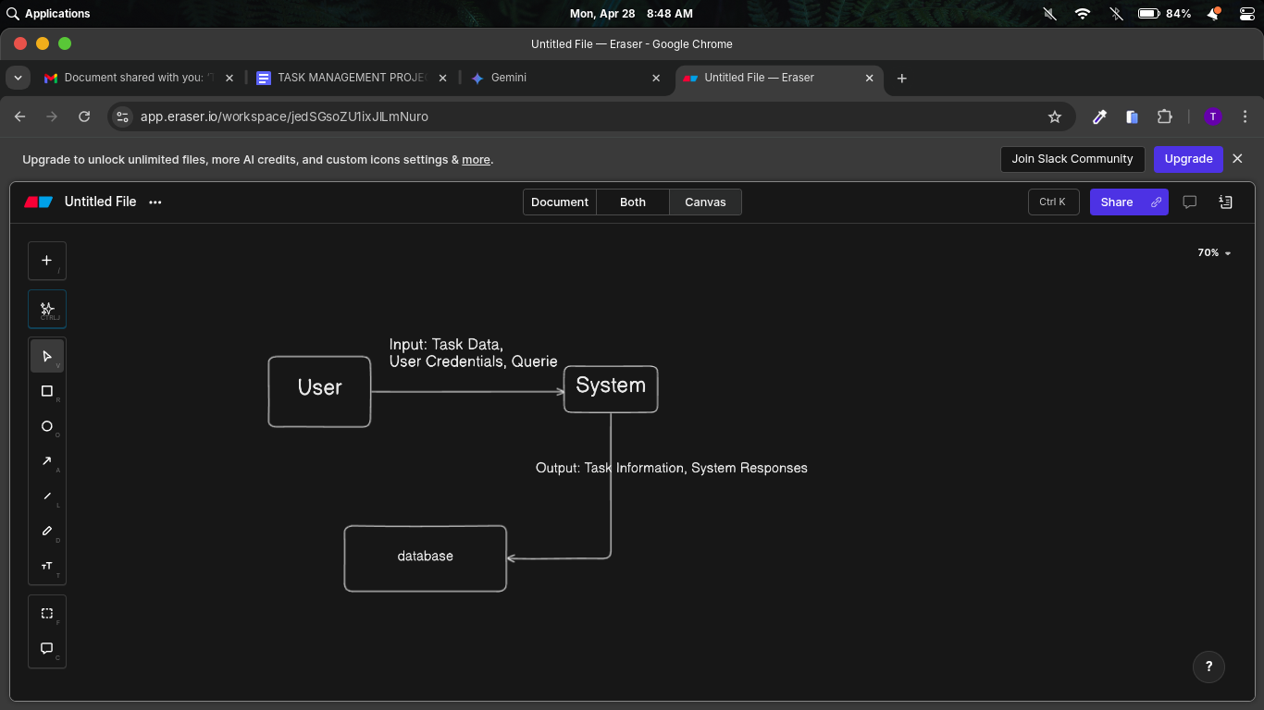
- This top-level diagram shows the overall interaction between the User, the Task Management System, and the Database.

Level 1: Detailed Data Flows
- Task Creation Flow:
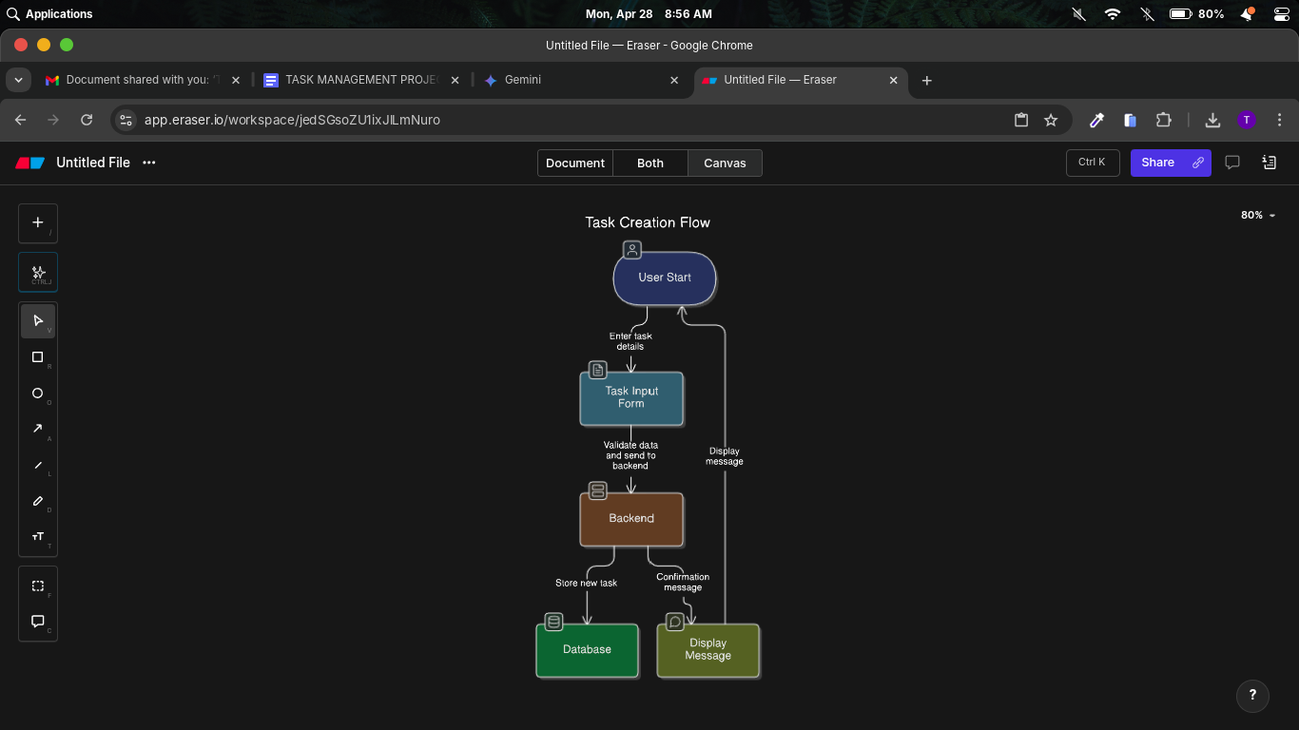

Task Update Flow:
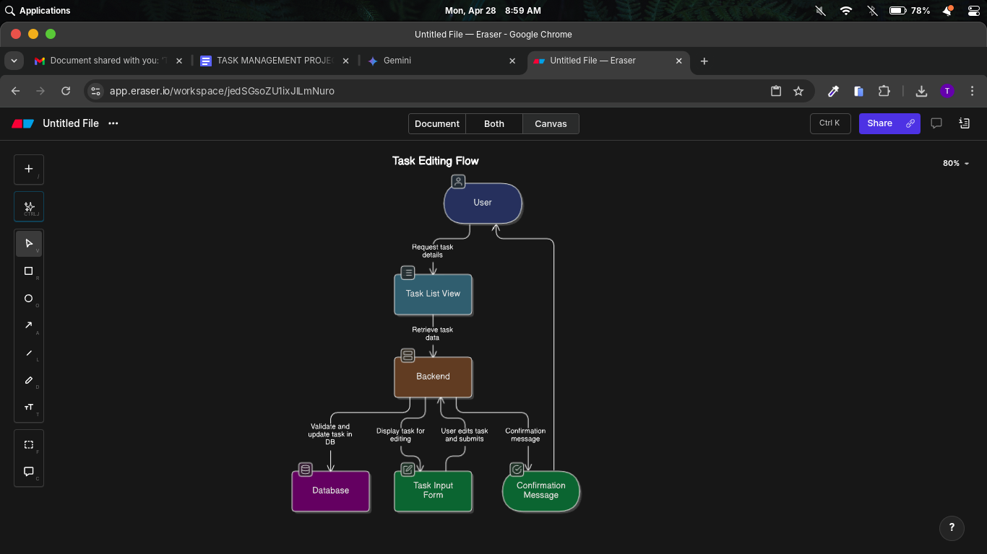
Task Deletion Flow:
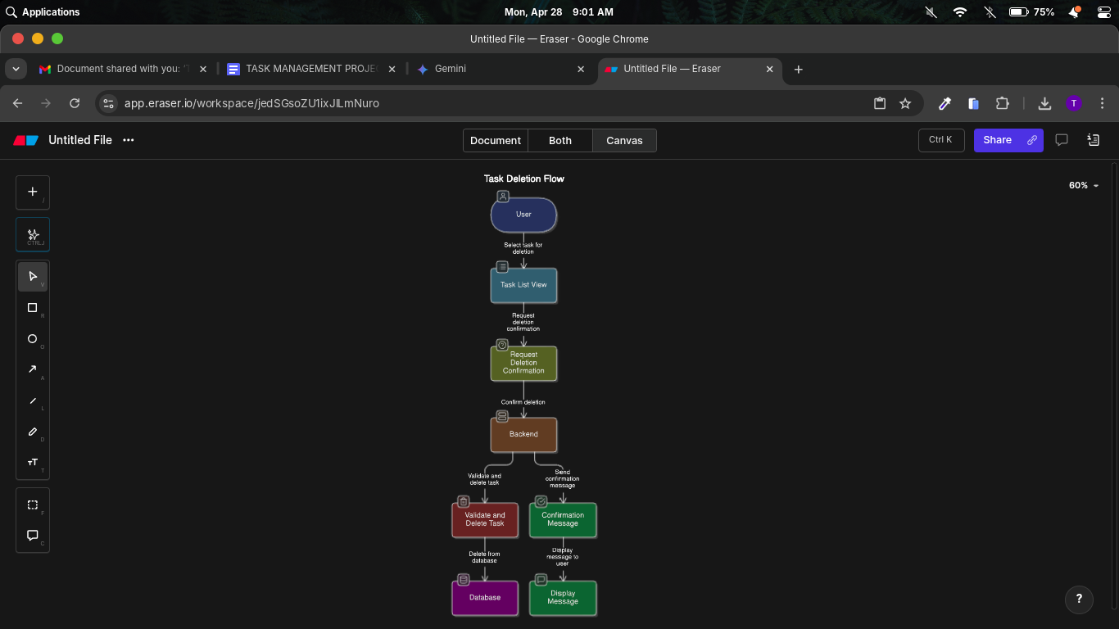

4.2.1 ER Diagram (Entity-Relationship Diagram)
The ER Diagram visually represents the entities within the system and the relationships between them.
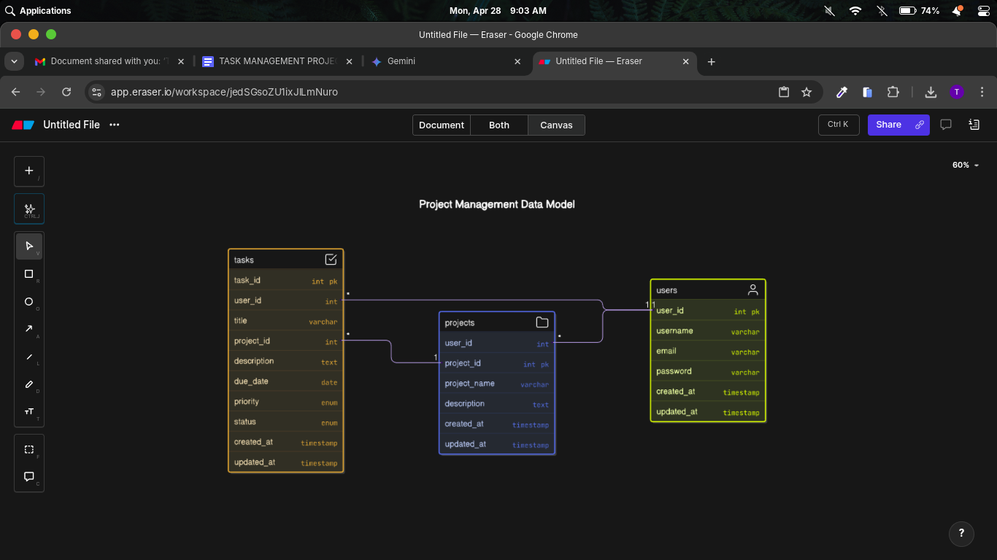

This diagram shows that a USER can create many TASKs (one-to-many relationship), and each TASK belongs to one PROJECT (many-to-one relationship). The user_id in the TASK and PROJECT tables acts as a Foreign Key linking back to the USER table.

4.2.2 System Flowchart
The system flowchart outlines the general flow of user interaction within the Task Management Website.

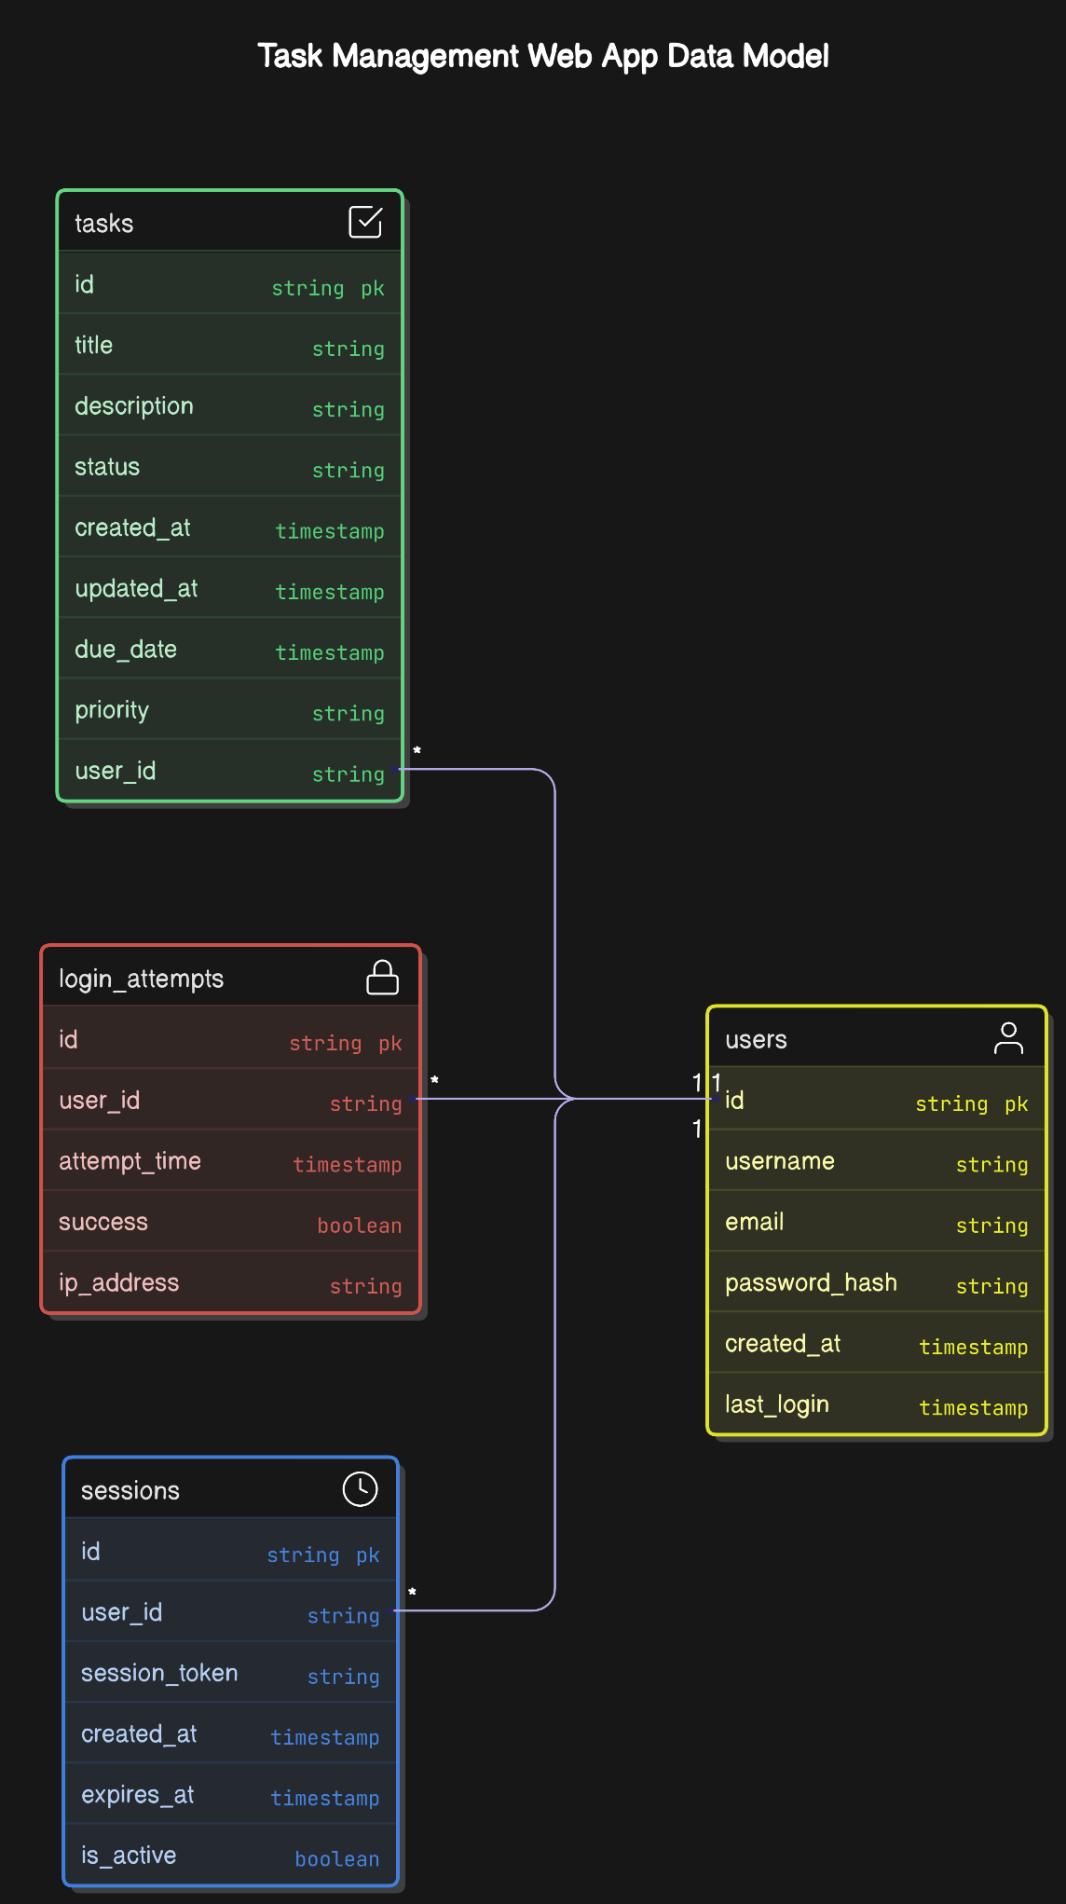

This flowchart illustrates the main user flows, including logging in, creating, editing, deleting, and viewing tasks, as well as applying filters and sorting.

Chapter 5: Mechanism Used
This chapter outlines the methodologies and mechanisms utilized throughout the development lifecycle of the Task Management Website, focusing on the testing strategies to ensure quality and the incrementation approach for iterative development.
5.1 Testing Mechanism
A comprehensive testing strategy is crucial to ensure the reliability, functionality, and performance of the Task Management Website. The following levels of testing are employed:
- 5.1.1 Unit Testing: Unit testing involves testing individual, isolated components or functions of the application in isolation. The goal is to verify that each unit of code works correctly and as expected. For example:
  - Testing the createTask function in the backend to ensure it correctly saves task data to the database and handles various input scenarios (e.g., missing fields, invalid data types).
  - Testing individual React components in the frontend to ensure they render correctly based on different props and handle user interactions as designed (e.g., the task creation form's input validation).
  - Utilizing testing frameworks specific to the technologies used (e.g., Jest or Mocha for JavaScript unit tests). This helps in identifying and fixing bugs early in the development process, leading to a more stable and robust application.
- 5.1.2 Integration Testing: Integration testing focuses on verifying the interactions and communication between different modules or components of the application. This is particularly important for ensuring the seamless flow of data between the frontend and the backend API. Examples include:
  - Testing the API endpoints for task creation to ensure that data sent from the React frontend is correctly received, validated, and processed by the Node.js/Express.js backend, and the appropriate response is sent back.
  - Testing the authentication flow to ensure that user login requests are correctly handled by the backend, a JWT is generated upon successful authentication, and subsequent requests with valid tokens are authorized.
  - Utilizing tools like Postman or Insomnia for manual API testing and integration testing frameworks within the codebase to automate these tests. This level of testing ensures that the different parts of the system work together harmoniously.
- 5.1.3 System Testing: System testing involves testing the entire Task Management Website as a complete and integrated system. This type of testing simulates real-world user scenarios and workflows to evaluate the overall functionality, performance, and usability of the application. Examples include:
  - Testing the entire user workflow from logging in, creating a new task with all relevant details, categorizing it under a project, setting a due date and priority, viewing the task in the task list, updating its status, and finally logging out.
  - Performing performance testing to ensure the application can handle the expected user load and that page loading times remain within acceptable limits.
  - Conducting basic security testing to verify that unauthorized access to protected resources is prevented. This level of testing validates that all the individual components and their integrations function correctly to meet the overall system requirements.
5.2 Incrementation Mechanism
The development of the Task Management Website follows an Agile methodology, which emphasizes iterative development, collaboration, and flexibility in response to evolving requirements. The core of the incrementation mechanism is based on Sprints:
- Agile Methodology: This approach involves breaking down the entire project into smaller, manageable iterations called sprints. Each sprint has a defined duration (typically 2-4 weeks) and focuses on delivering a specific set of features or improvements to the Task Management Website.
- Sprints (2-4 weeks per feature): During each sprint, the development team works on designing, implementing, testing, and deploying a specific set of functionalities. For example, the first sprint might focus on user registration and login, while the second sprint could address task creation and basic viewing. This iterative approach allows for early and continuous delivery of working software.
- Continuous feedback & improvements: At the end of each sprint, the delivered features are reviewed, and feedback is gathered from stakeholders (e.g., potential users, project managers). This feedback is then incorporated into the planning of subsequent sprints, allowing for continuous improvement and adaptation of the application based on real needs and insights. This iterative cycle of development, feedback, and refinement ensures that the final product aligns closely with user expectations and business goals.

Chapter 6: Future Scope
The CompanyBuddy - Task Management System has a strong foundation, and several exciting avenues for future development and enhancement can further enrich its functionality and user experience.
- Mobile App Development (React Native/Flutter): To provide users with seamless access to CompanyBuddy on the go, future development will focus on creating native mobile applications for both iOS and Android platforms. Utilizing cross-platform frameworks like React Native or Flutter will allow for efficient development of apps that share a significant portion of the codebase, ensuring consistency in features and user experience across web and mobile. This will enable users to manage tasks, receive real-time updates, and collaborate with their teams anytime, anywhere, improving accessibility and responsiveness.
- AI-based Task Prioritization: Integrating Artificial Intelligence (AI) to assist with task prioritization presents a significant opportunity to enhance user productivity. Future features could include an AI engine that analyzes task deadlines, dependencies, urgency levels, and potentially even user work patterns to suggest optimal task prioritization. This intelligent system could help users focus on the most critical tasks at the right time, improving efficiency and reducing the risk of missed deadlines. Machine learning algorithms could be trained on user behavior and project outcomes to provide increasingly accurate and personalized prioritization recommendations.
- Third-party Integrations (Google Calendar, Slack): To further streamline workflows and integrate CompanyBuddy seamlessly into users' existing toolsets, future development will include integrations with popular third-party applications.
  - Google Calendar Integration: This integration would allow users to synchronize task deadlines and important project milestones with their Google Calendar, providing a unified view of their schedules and commitments. Bi-directional syncing could enable updates in either platform to reflect automatically in the other.
  - Slack Integration: Integrating with Slack, a widely used team communication platform, would facilitate real-time notifications and updates within project channels. Users could receive alerts for new tasks, task status changes, upcoming deadlines, and comments directly within their team's Slack workspace, improving communication and awareness.
Chapter 7: References and Bibliography
This project has benefited from a wealth of online resources and established literature in the field of web development and software engineering. The following resources were consulted and provided valuable guidance:
- MDN Web Docs (Mozilla Developer Network): A comprehensive resource for web standards, including HTML, CSS, and JavaScript. MDN provides in-depth documentation, tutorials, and best practices that were crucial for developing the frontend of CompanyBuddy.
- W3Schools: Another widely used educational website offering tutorials and references for web development technologies, providing quick and accessible information on various aspects of HTML, CSS, JavaScript, and related technologies.
- Stack Overflow: A question-and-answer website for programmers, serving as an invaluable resource for troubleshooting technical challenges, finding solutions to specific coding problems, and learning from the collective knowledge of the developer community.
- Books:
  - "Clean Code: A Handbook of Agile Software Craftsmanship" by Robert C. Martin: This book provides essential principles and best practices for writing clean, maintainable, and readable code, which has been instrumental in ensuring the quality and longevity of the CompanyBuddy codebase.

